Advanced SQL

Q1. What is a Common Table Expression (CTE), and how does it improve SQL query readability?
Ans 1: A Common Table Expression (CTE) is a temporary, named result set that you can reference within a SELECT, INSERT, UPDATE, or DELETE statement.
It improves readability by breaking down complex queries, particularly nested subqueries, into simple, logical, and sequential building blocks.
Because a CTE is defined at the top of the query using the WITH clause, it allows developers to read the query's logic from top to bottom.

Q2. Why are some views updatable while others are read-only? Explain with an example.
Ans 2: An updatable view maps directly back to the rows of a single base table without any ambiguity, allowing the database engine to translate UPDATE, INSERT, or DELETE operations on the view into operations on the underlying table.
A read-only view contains complex logic, such as JOIN operations, GROUP BY clauses, aggregate functions (like SUM or COUNT), or DISTINCT keywords, which makes it impossible for the database engine to accurately trace a modification back to a specific row in the base table.
Example: A simple view showing only the names and emails of active employees from an Employees table is updatable. Conversely, a view showing the SUM(Salary) grouped by DepartmentID is read-only because modifying the sum cannot logically be applied to the individual salaries making up that total.

Q3. What advantages do stored procedures offer compared to writing raw SQL queries repeatedly?
Ans 3: The following are the advantages which stored procedures offer compared to writing raw SQL queries repeatedly:
- Performance: Stored procedures are compiled and optimized by the database engine upon creation, often resulting in faster execution times than dynamically executing raw SQL queries every time.
- Security: They help prevent SQL injection attacks by using parameters and allow database administrators to grant users permission to execute the procedure without granting them direct access to the underlying tables.
- Maintainability and Reusability: The SQL logic is stored in one centralized location inside the database, meaning updates to the logic only need to be made once, and multiple applications can reuse the same procedure.
- Reduced Network Traffic: Instead of sending hundreds of lines of raw SQL code over the network, the application only sends the name of the stored procedure and its parameters.

Q4. What is the purpose of triggers in a database? Mention one use case where a trigger is essential.
Ans 4: A database trigger is a specialized stored program that automatically executes (or "fires") in response to specific data modification events (INSERT, UPDATE, or DELETE) occurring on a table.
Their primary purpose is to enforce business rules, maintain data integrity automatically, or log historical actions without requiring the application layer to explicitly call them.
Use Case: Audit logging is a highly essential use case. A trigger can be set up to automatically record exactly who changed a record, what the old and new values were, and when the change occurred into a separate audit table.

Q5. Explain the need for data modelling and normalization when designing a database.
Ans 5: Data Modelling: This creates a visual blueprint or structured architecture of the database system, ensuring that all data requirements are accurately mapped out, relationships between entities are defined, and the database aligns directly with business logic before any code is written.
Normalization: This is the systematic process of organizing data to minimize redundancy and eliminate data anomalies (insertion, update, or deletion anomalies).
By dividing large, unwieldy tables into smaller, related ones and linking them using foreign keys, normalization ensures data integrity and saves storage space.

Q6: Q6. Write a CTE to calculate the total revenue for each product, and return only products where revenue > 3000.
Ans 6:
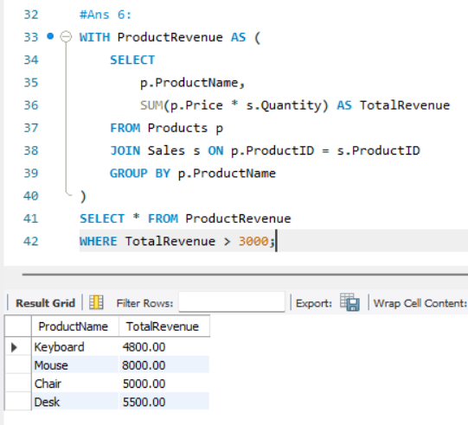

Q7. Create a view named vw_CategorySummary that shows: Category, TotalProducts, AveragePrice.
Ans 7:
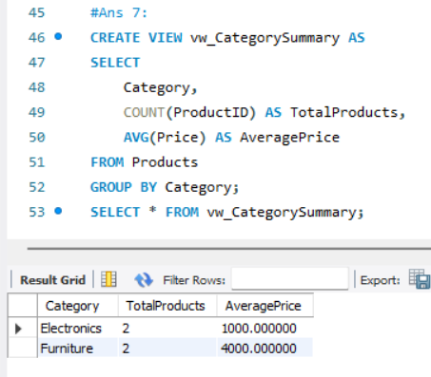

Q8. Create an updatable view containing ProductID, ProductName, and Price. Then update the price of ProductID = 1 using the view.
Ans 8:
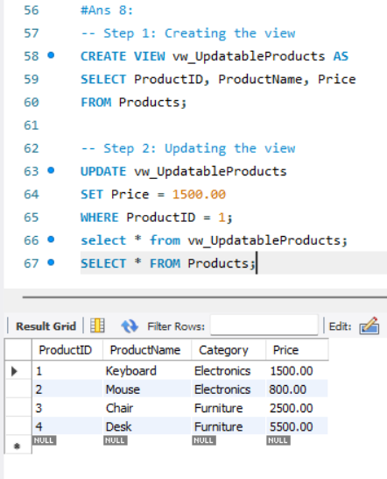

Q9. Create a stored procedure that accepts a category name and returns all products belonging to that category.
Ans 9:
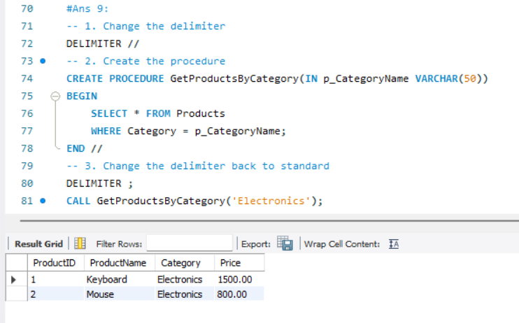

Q10. Create an AFTER DELETE trigger on the Products table that archives deleted product rows into a new table ProductArchive. The archive should store ProductID, ProductName, Category, Price, and DeletedAt timestamp.
Ans 10:
